**Lab 1: Getting to Know Your DualShock 4**

**Objectives:**

* Get familiar with the DualShock 4
* Do some basic problem solving using the DualShock 4

**Starting Point:**

None needed.

**Process:**

**Folder organization**

* 1. Open the “Cygwin Terminal.” (“Start>Cygwin>Cygwin Terminal”). For the moment, minimize this window. We will use it later.
  2. Open Windows Explorer (“Start>Computer”).
  3. Click on U: drive in the new window.

**Important!** Get in the habit of using your U: drive to save all of your files. The U: [drive](https://it.engineering.iastate.edu/how-to/engineering-home-directory/) is network storage (5 GB) that you can access from any Windows computer in any Engineering lab on campus; the C: drive is cleared regularly and is only local to that one machine. You will need to routinely access past work no matter the PC. **Saving to the C: drive is unacceptable.**

* 1. Create a folder in your U: drive called *CprE185*
  2. Double-click on *CprE185* to open it.
  3. This is your home folder for work with Cygwin for the semester.
  4. Create a new folder in *CprE185* named *lab1*.
  5. Copy ds4rd.exe to *lab1*. (Your TA will show you where to find it on BlackBoard)
  6. Minimize this window.

**Collecting Data**

In this section, we will grab some data off of the DualShock 4 to support your first homework. The DualShock 4 has 6-axis motion sensing. It has 3-axis accelerometer and 3-axis gyroscope readings. We will take the data off of the DualShock 4 using ds4rd.exe.

1. Your TA will go through connecting your DualShock 4 to your PC. You can either use Bluetooth or connect with a micro USB cable. The controller should be paired with your desktop in the lab already.  **DO NOT TRY TO PAIR THE CONTROLLER YOURSELF.**
2. The controller has a number on it and the monitor of the computer has a number on it. Match the DS4 number with the monitor number as shown in the pictures below

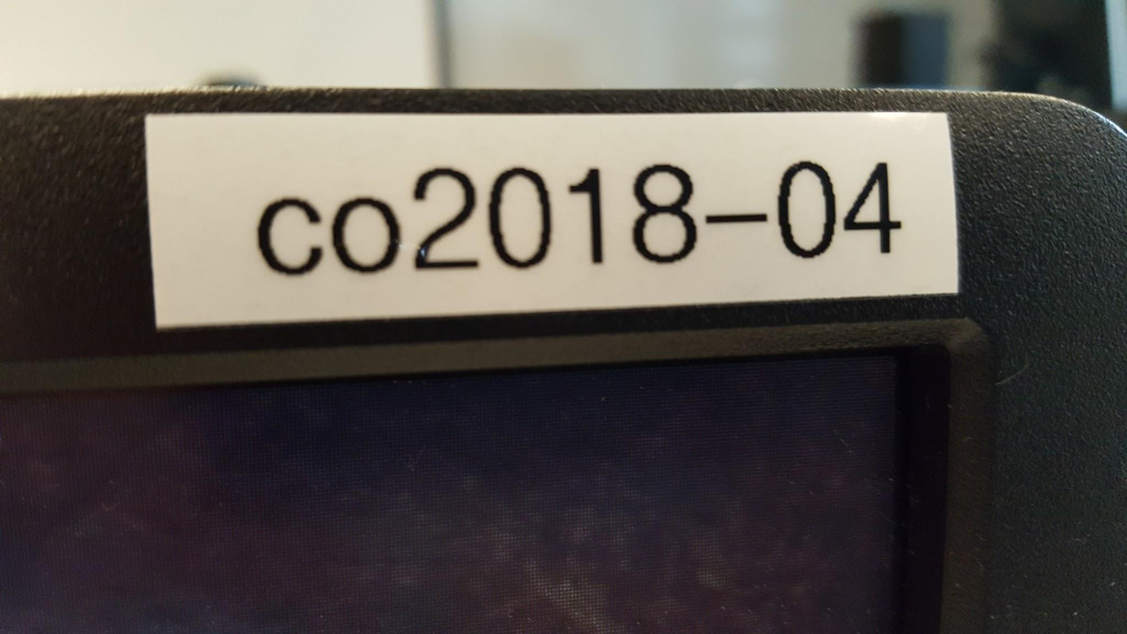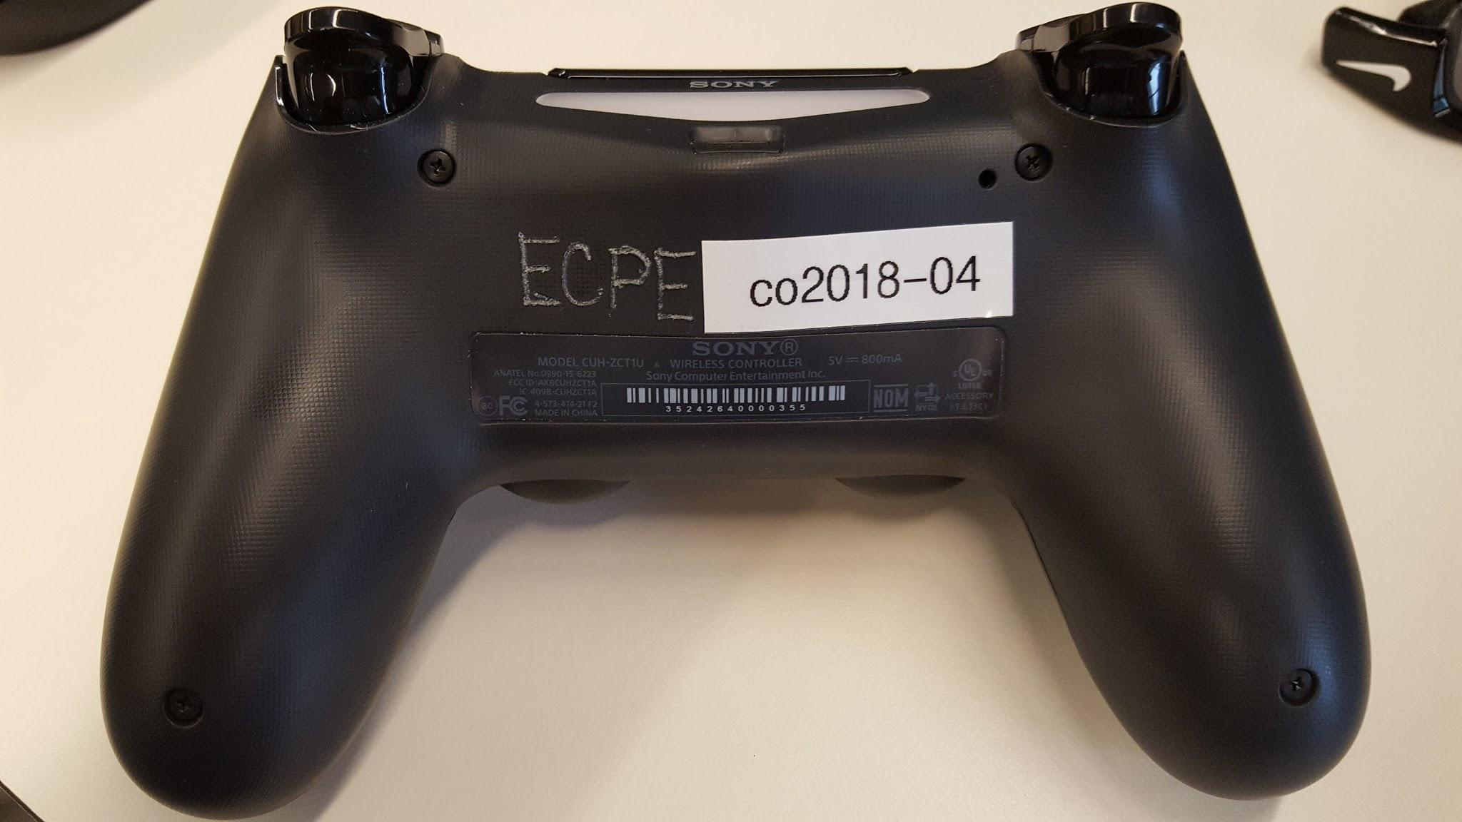

1. Basic cygwin commands:

cd change directory cd U:, cd lab1, cd ..

ls list contents for current directory ls

mkdir make directory mkdir lab1

up arrow history of commands you have previously entered

tab auto complete what you are typing

1. Using the Cygwin Terminal from earlier and the basic commands above, navigate

to the folder that has ds4rd.exe in it.

To run ds4rd.exe, you will use a command similar to:

**./ds4rd.exe -d 054c:09CC -D DS4_BT -t -g**

-d is the type of interface, -D is how it is connected to your Windows computer (DS4_BT means via bluetooth and DS4_USB means using the micro usb cable). You will determine what t and g are as part of this lab.

1. Move the DualShock 4 around to see how changing directions and orientations changes some of the numbers. Hit Control+C to stop the program. Take special notice of the numeric values when holding the DualShock 4 level in different orientations.
2. Now, collect the following data samples (when you use ‘**>**’ the data is being redirected to a file so you will not see it on the screen):
   * Place the DualShock 4 flat on the table and use the following to collect data for roughly 10 seconds.

**./ds4rd.exe -d 054c:09cc -D DS4_BT -t -g** **> flat1.csv**

* Turn the DualShock 4 over, and while holding the DualShock 4 level do another 10 seconds.

**./ds4rd.exe -d 054c:09cc -D DS4_BT -t -g** **> flat2.csv**

* + Hold the DualShock 4 such that the light bar is pointing upward and record another 10 seconds.

**./ds4rd.exe -d 054c:09cc -D DS4_BT -t -g** **> front1.csv**

* Turn the DualShock 4 over so the light bar is pointing down and do another 10 seconds. If you are connected with a micro usb cable, the cable may be slightly in your way.

**./ds4rd.exe -d 054c:09cc -D DS4_BT -t -g** **> front2.csv**

* + Choose some simple movement of the DualShock 4, not the joysticks, that is easy to reproduce. Collect 2 files of data as above using the same movement. Save as **custom1.csv** and **custom2.csv**

**Save these files for your lab report.** You do not need to turn them in with this lab, but be sure you save the files so you can use them later for graphs required in the lab report.

Be sure you have recorded all data requested before you leave the room. It is common for students to overwrite their files (forget to rename between flat1.csv and flat2.csv.) Please double check that you have all the files you need to finish your lab writeup.

**Joystick Equation**

In this section, you will formulate an equation that takes in raw joystick values and outputs a number in the range -1 to 1. There are questions about your equation in the homework.

1. To start, observe the output of the following:

**./ds4rd.exe -d 054c:09cc -D DS4_BT -j**

* 1. Move the left joystick left and right.
  2. Move the right joystick left and right
  3. Move both joysticks up and down
  4. Release both joysticks and let them center themselves

1. Create an algebraic expression for the horizontal axis that converts the joystick data given to a number between -1 (left) and 1 (right).
2. Do the same for the vertical axis where -1 is the bottom and 1 is the top.
3. Given the fourth dataset, what would be the expression’s output whenever the joysticks are in the center? Is it near 0? What’s going on?

**Turn - In**

**Upload one .pdf file** containing the following before the due date (Ask TA where due date can be found). Homework is to be completed individually and typed (except base conversions which can be handwritten, but scanned and included in the single PDF submission).

1. Completed homework below

**Lab 1 Companion Homework**

If you need help with spreadsheets and creating a scatterplot, the following tutorial may help. You may also ask your TA for help.

[*https://docs.google.com/document/d/1bsyHjWL13wu3385pf0PHAhJ81zszxp7keIsU6OU55so/edit*](https://docs.google.com/document/d/1bsyHjWL13wu3385pf0PHAhJ81zszxp7keIsU6OU55so/edit)

**1. Old Computers**

On the following page, you will find some of the historically important personal computers. Despite their obsolescence, all of the important modern day computing principles were present in them in one way or another. Not all computers are on this web site. You may need to do a google search for some of them. However, this URL will get you started.

<http://www.oldcomputers.net/indexwp.html>

For each of the following computers, describe their input/output devices, give the minimum and maximum amount of RAM (memory) available in the system in kilobytes as well as in bytes and bits, and what CPU is used.

1.1 MITS Altair 8800

1.2 MOS KIM-1

1.3 Apple 1

1.4 IBM Personal Computer (PC) 5150

1.5 Apple Macintosh

**2. Base Conversion**

Learning binary and other numbering systems is an important skill for computer and software engineers. Write the following in decimal (base 10), binary, octal (base 8), and hexadecimal. Show your work ***by hand*** (don’t forget to scan your work and put it in your PDF).

Decimal 1, 10, 42, 255

Hexadecimal F, DF, 81, 04

Binary 10010011, 111111

**3. Exploration**

Steps

1. Load your data from lab 1 (flat1.csv, flat2.csv) into a spreadsheet.
2. Do a scatter plot of the 3 right columns on the y-axis against the leftmost column on the x-axis for each file. Each scatter plot for each file will look something like the image below.

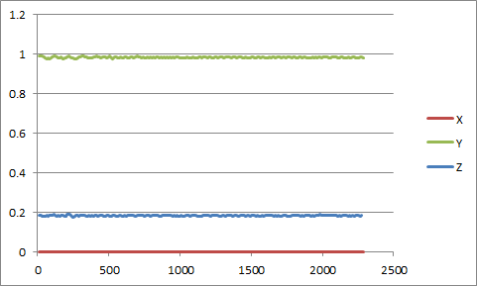

1. Do the same for front1 and front2 and then for custom1 and custom2.
2. Include all of these plots in your PDF, one per page. They should be accurately labeled (front1, front2, etc.) so the grading TAs can understand your work.
3. You should have 6 pages of graphs.

Questions (The first few paragraphs of <http://www.dimensionengineering.com/info/accelerometers> may help you out. But it won't give you the answers. You need to think about these questions.)

1. What do you think each column of data represent?
2. How does this relate the the flags (-t and -g) that you used?
3. What unit of measure are the data in?
4. On each of your plots, explain what is going on. Try to understand why the graphs look like they do and then relate the graphs to what you did when you took the data. Label, on your computer or by hand (scan and include in your PDF), parts of the graphs and then describe what is going on.

**4. Joystick Calibration**

1. What are you vertical and horizontal joystick equations? Are they similar or not? Why or why not?
2. What did you find as the center point? Explain why it is or is not 0?
3. What could cause the center to not be 0?
4. What could you change to make the center be 0?